**11.1 *Test Case NO:- 1:-***

**Test Case Name:- Sign up**

|  |  |  |  |  |
| --- | --- | --- | --- | --- |
| **Test Case SLno** | **Test Data** | **Expected** | **Actual** | **Status**  **(pass / fail)** |
| 1 | <correct name>  <correct email>  <correct phone>  <correct address>  <correct pin code>  <correct blood group>  <correct state>  <correct city>  <correct password>  <correct confirm password>  <correct age> | Successful sign up | Successful sign up | pass |
| 2 | <correct name>  <correct email>  <correct phone>  <correct address>  <correct pin code>  <correct blood group>  <correct state>  <correct city>  <correct password>  **<incorrect confirm password>**  <correct age> | Unsuccessful sign up | Unsuccessful sign up | pass |
| 3 | <correct name>  **<incorrect email>**  <correct phone>  <correct address>  <correct pin code>  <correct blood group>  <correct state>  <correct city>  <correct password>  <correct confirm password>  <correct age> | Unsuccessful sign up | Unsuccessful sign up | pass |

|  |  |  |  |  |
| --- | --- | --- | --- | --- |
| **Test Case NO** | **Test Data** | **Expected** | **Actual** | **Status**  **(pass / fail)** |
| 4 | <correct name>  <correct email>  <correct phone>  <correct address>  <correct pin code>  <correct blood group>  <correct state>  <correct city>  <correct password>  <correct confirm password>  **<incorrect age>** | Unsuccessful sign up | Unsuccessful sign up | pass |

* **Test Case 1 SLNO 1:-**

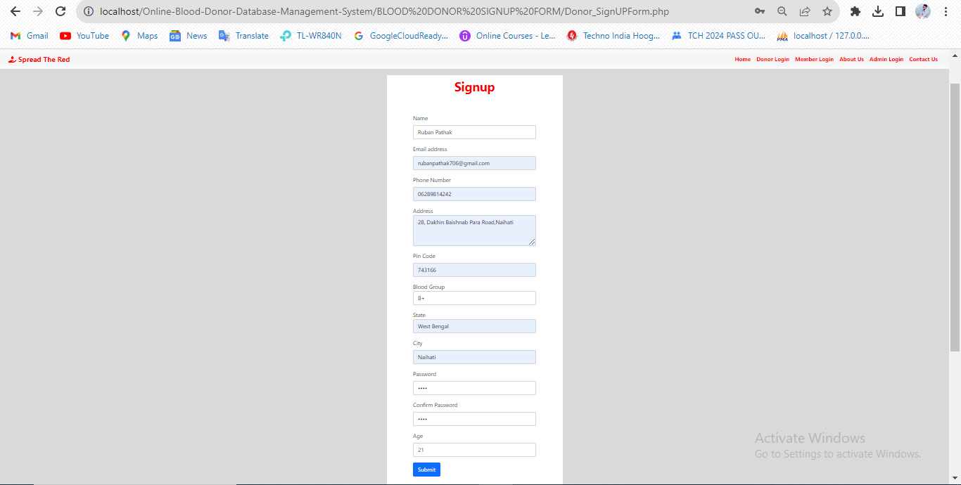

* **Test Case 1 SLNO 2:-**

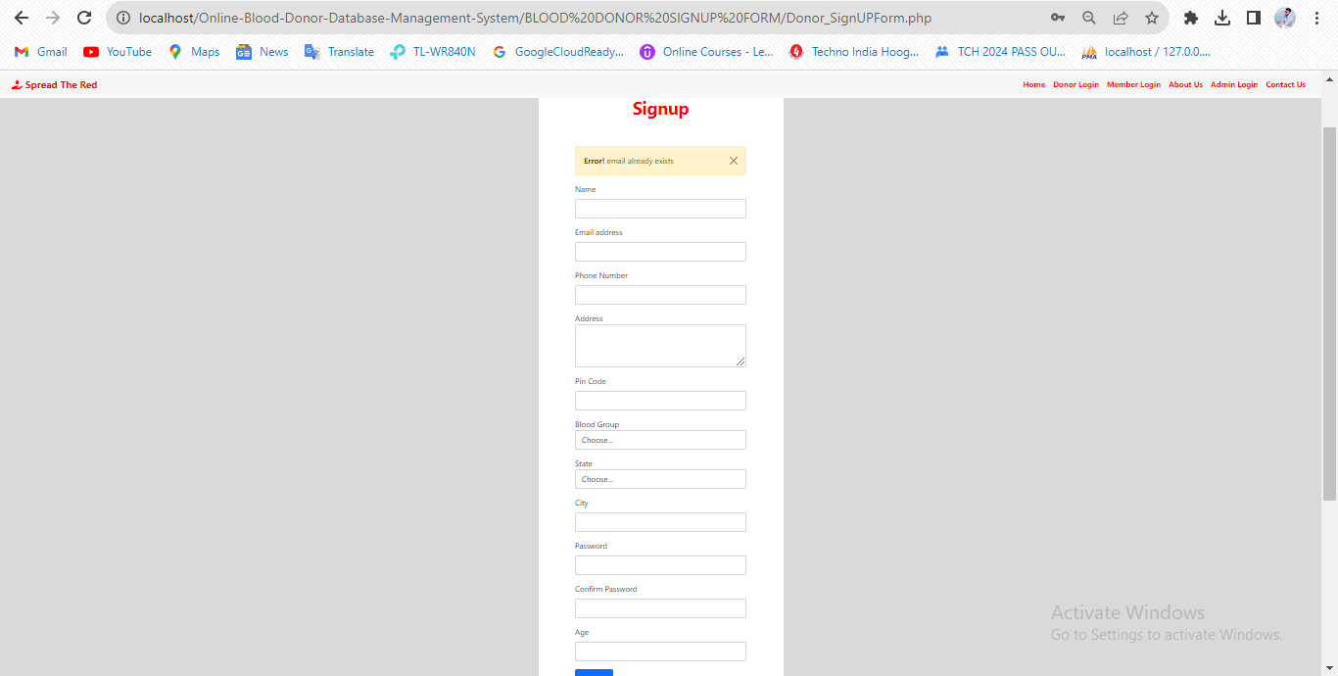

* **Test Case 1 SLNO 3:-**

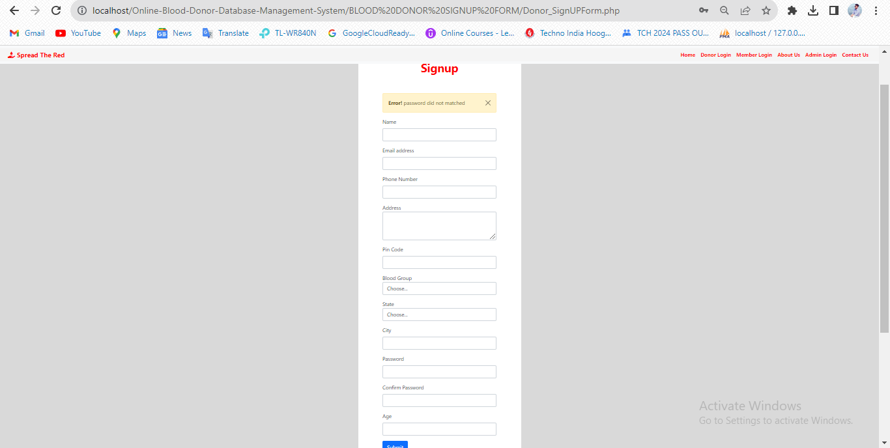

* **Test Case 1 SLNO 4:-**

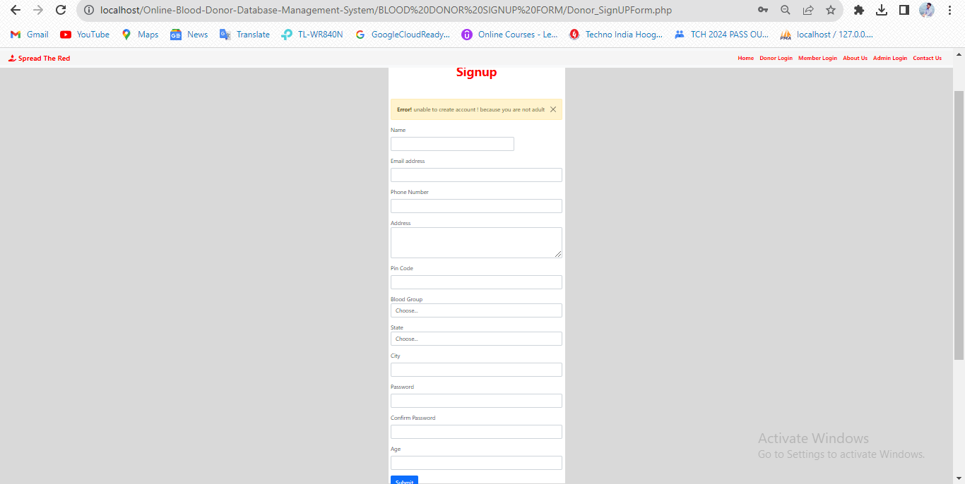

**11.2 *Test Case NO:- 2:-***

**Test Case Name:- Log In**

|  |  |  |  |  |
| --- | --- | --- | --- | --- |
| **Test Case NO** | **Test Data** | **Expected** | **Actual** | **Status**  **(pass / fail)** |
| 1 | <correct email>  <correct password> | Successful log in | Successful log in | pass |
| 2 | **<incorrect email>**  <correct password> | Unsuccessful log in | Unsuccessful log in | pass |
| 3 | <correct email>  **<incorrect password>** | Unsuccessful log in | Unsuccessful log in | pass |
| 4 | <incorrect email>  <incorrect password> | Unsuccessful log in | Unsuccessful log in | pass |

* **Test Case 2 SLNO 1:-**

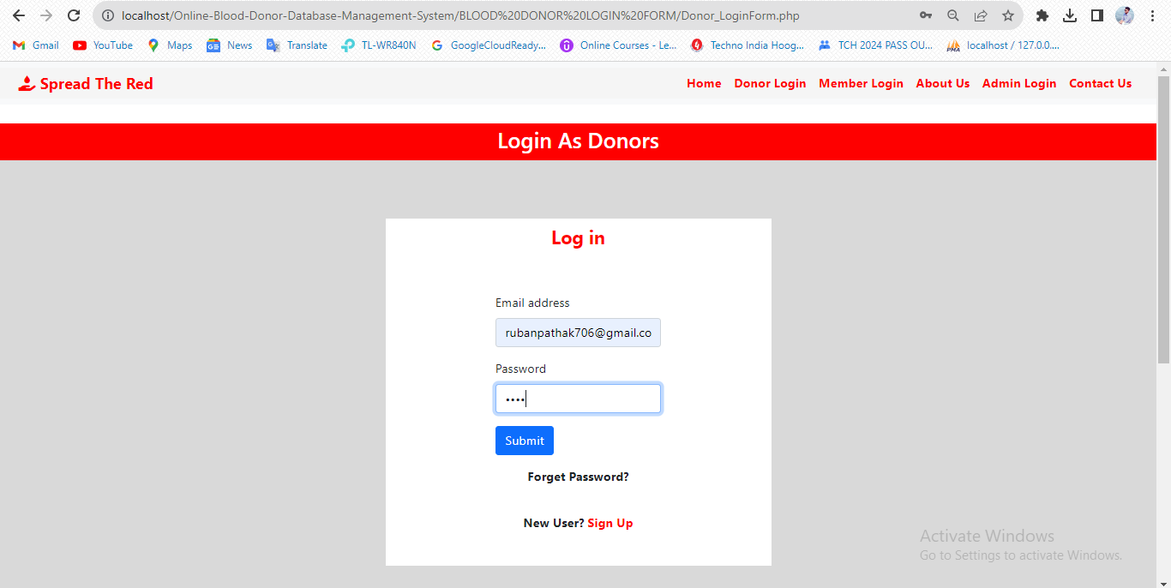

* **Test Case 2 SLNO 2:-**

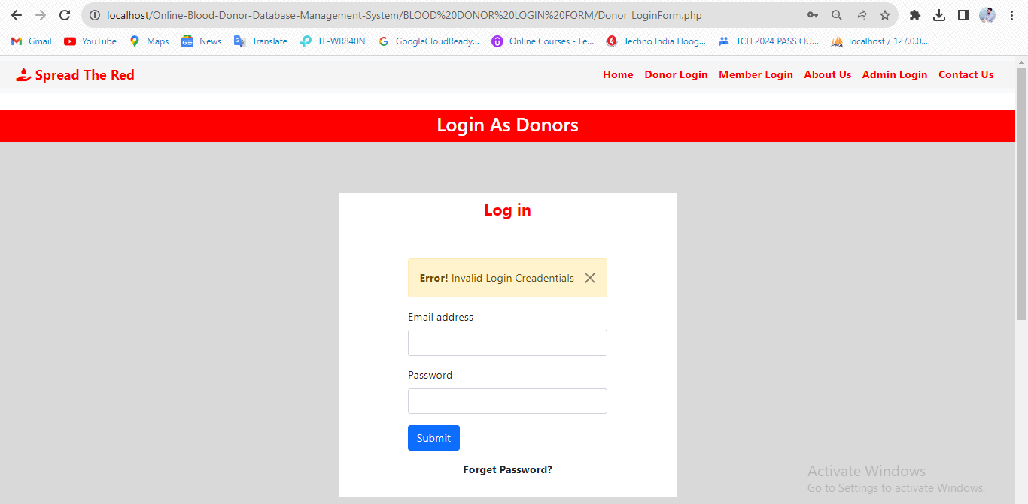

* **Test Case 2 SLNO 3:-**



* **Test Case 2 SLNO 4:-**



**11.3 *Test Case NO:- 3:-***

**Test Case Name:- Forget Password OTP Generate**

|  |  |  |  |  |
| --- | --- | --- | --- | --- |
| **Test Case NO** | **Test Data** | **Expected** | **Actual** | **Status**  **(pass / fail)** |
| 1 | <correct email>  <correct password>  <correct confirm password> | Successful OTP mail sent | Successful OTP mail sent | pass |
| 2 | **<incorrect email>**  <correct password>  <correct confirm password> | Unsuccessful OTP mail did not sent | Unsuccessful OTP mail did not sent | pass |
| 3 | <correct email>  **<incorrect password>**  **<incorrect confirm password>** | Unsuccessful OTP mail did not sent | Unsuccessful OTP mail did not sent | pass |

* **Test Case 3 SLNO 1:-**

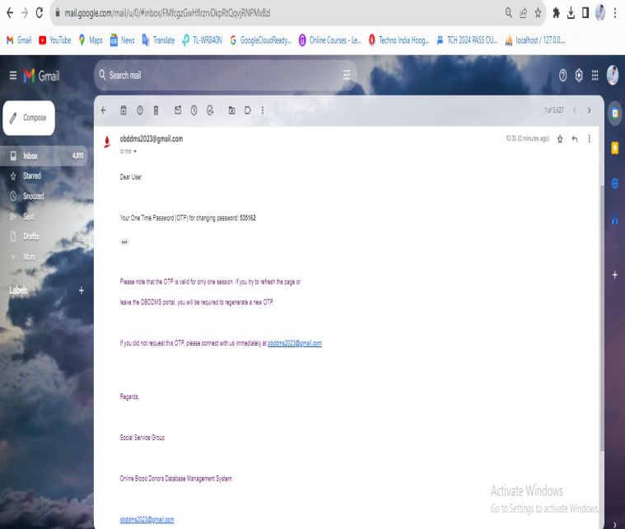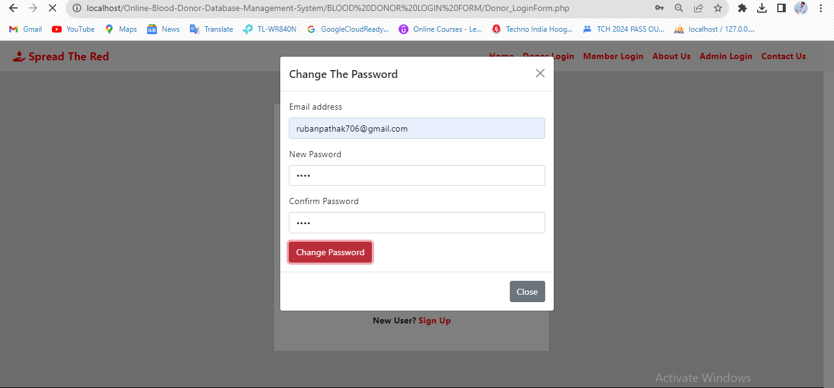

* **Test Case 3 SLNO 2:-**

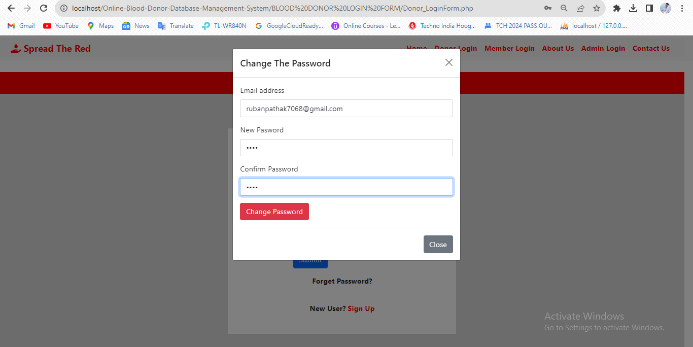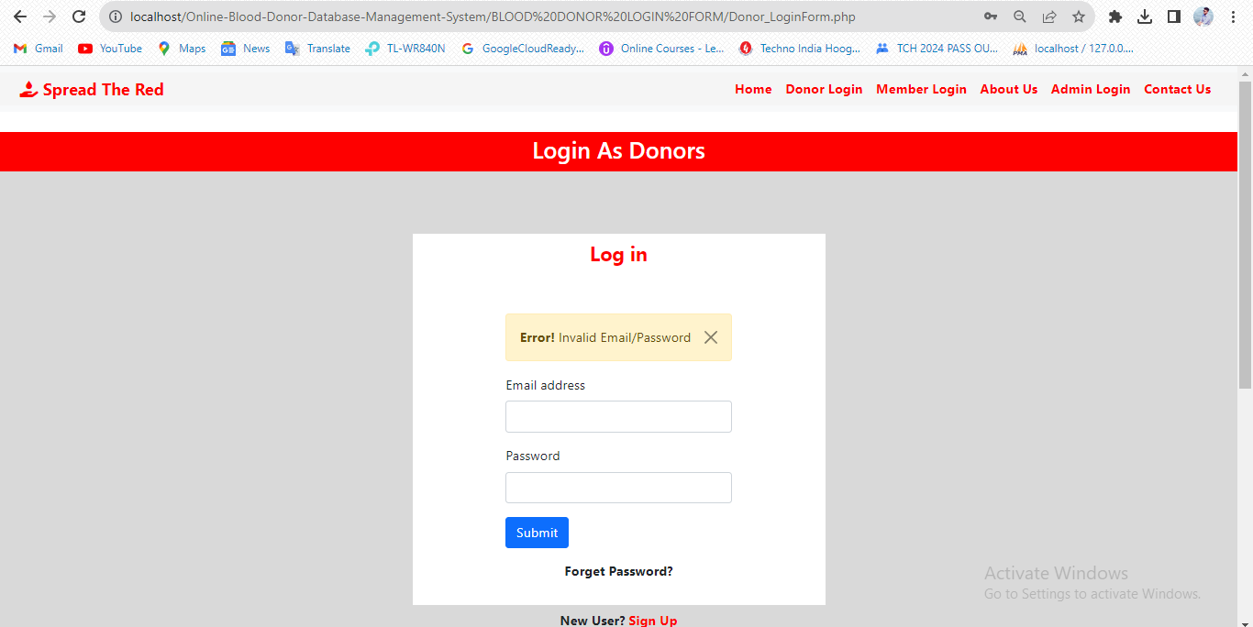

* **Test Case 3 SLNO 3:-**



**11.4 *Test Case NO:- 4:-***

**Test Case Name:- Forget Password OTP Matched**

|  |  |  |  |  |
| --- | --- | --- | --- | --- |
| **Test Case NO** | **Test Data** | **Expected** | **Actual** | **Status**  **(pass / fail)** |
| 1 | <correct OTP> | Successfully Password Changed | Successfully Password Changed | pass |
| 2 | **<incorrect OTP>** | Password did not changed | Password did not changed | pass |

* **Test Case 4 SLNO 1:-**

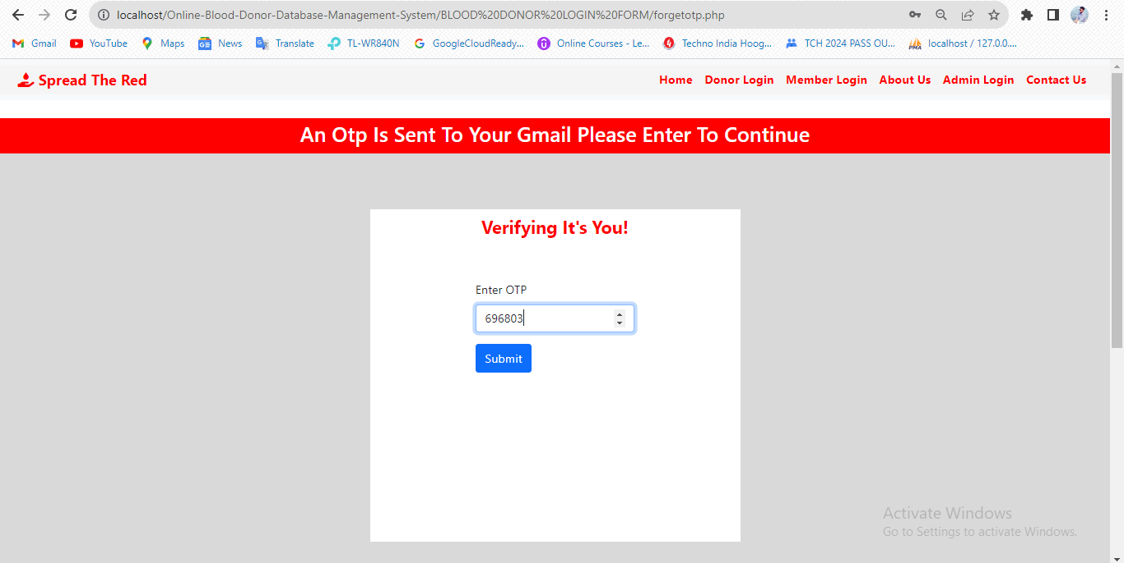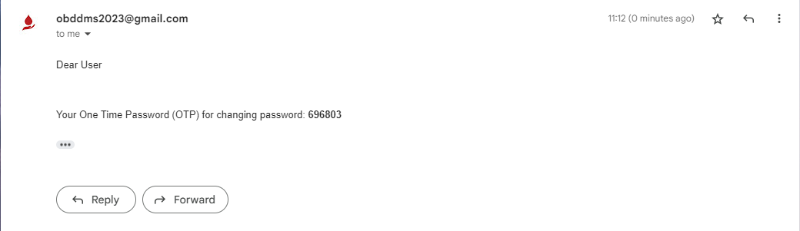

* **Test Case 4 SLNO 2:-**

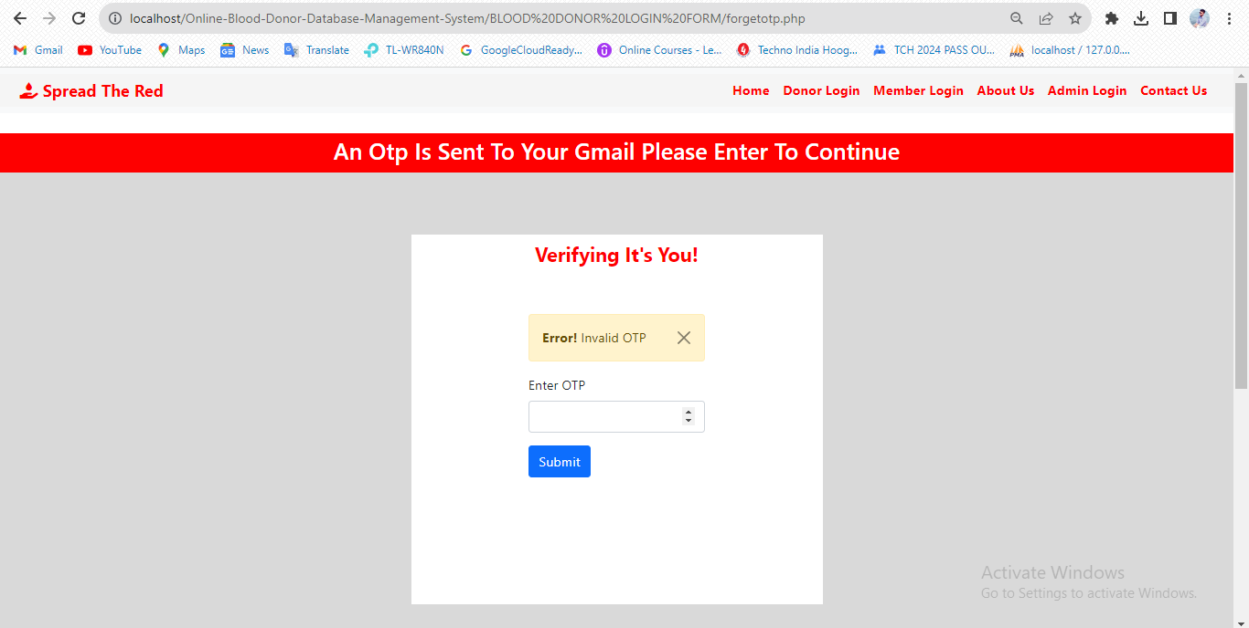

**11.5 *Test Case NO:- 5:-***

**Test Case Name:- Hide donor profile from all requesters (Availability Status)**

|  |  |  |  |  |
| --- | --- | --- | --- | --- |
| **Test Case NO** | **Test Data** | **Expected** | **Actual** | **Status**  **(pass / fail)** |
| 1 | <show profile> | Profile will be visible to all blood requesters | Profile will be visible to all blood requesters | pass |
| 2 | **<hide profile>** | Profile will be hidden to all blood requesters | Profile will be hidden to all blood requesters | pass |

* **Test Case 5 SLNO 1:-**

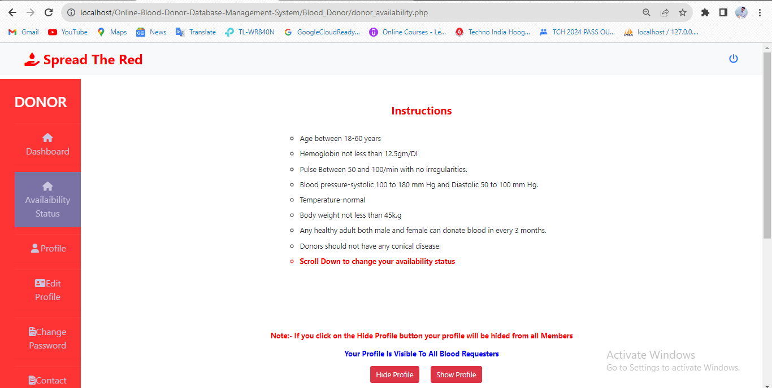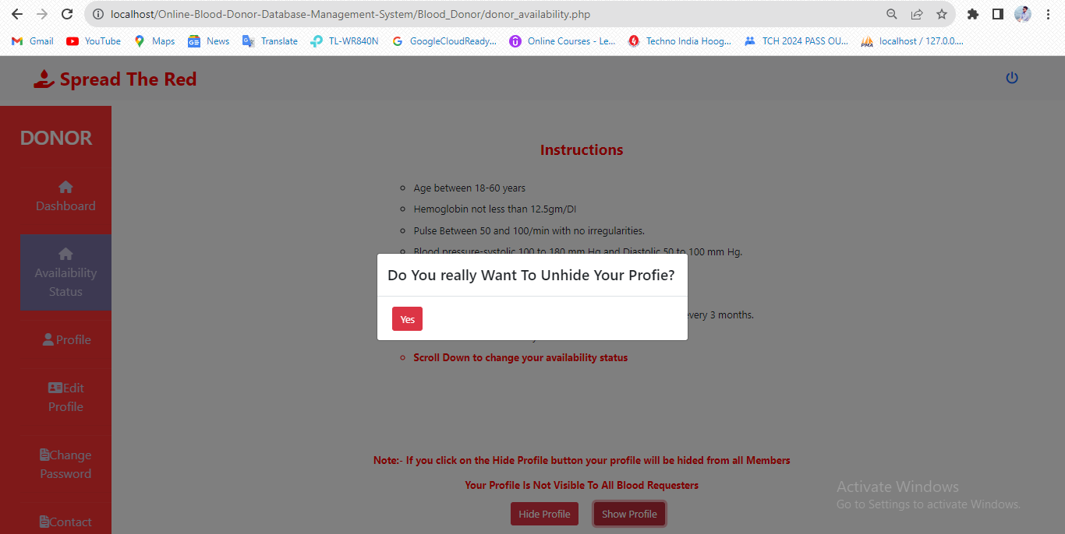

* **Test Case 5 SLNO 2:-**

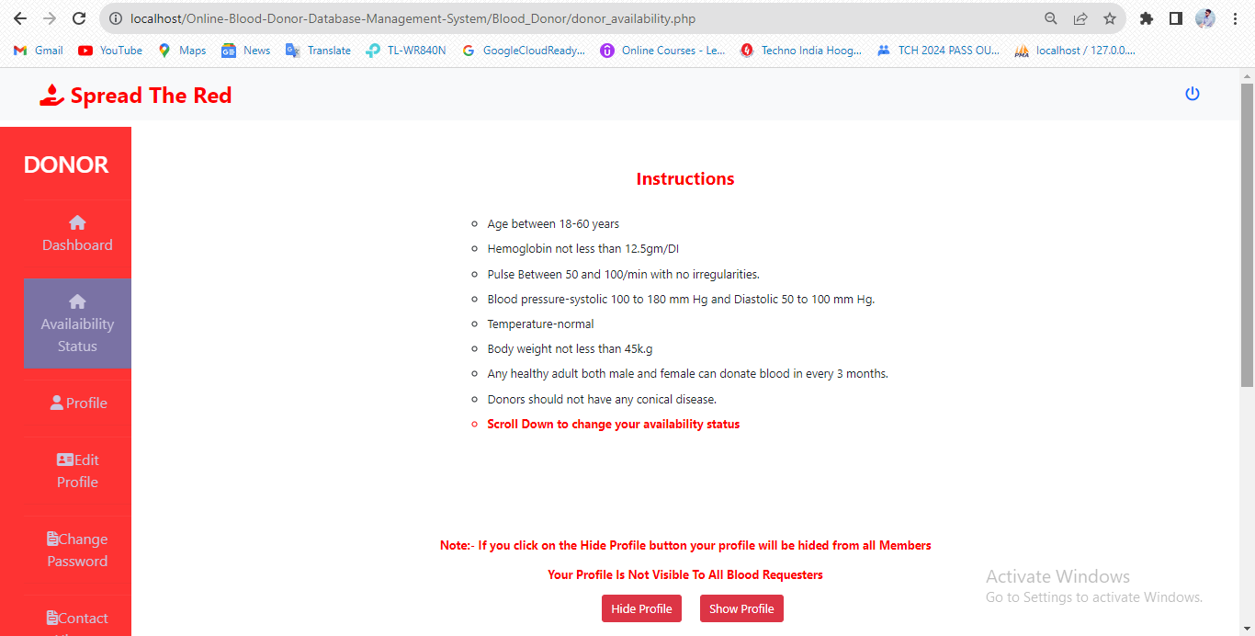

**11.6 *Test Case NO:- 6:-***

**Test Case Name:- Accept Request/Reject Request/Pending Request**

|  |  |  |  |  |
| --- | --- | --- | --- | --- |
| **Test Case NO** | **Test Data** | **Expected** | **Actual** | **Status**  **(pass / fail)** |
| 1 | <accept request> | Requester Phone Number Will Be shown and an email will be sent. | Requester Phone Number Will Be shown and an email will be sent. | pass |
| 2 | <reject request> | Requester Phone Number Will Be hided and an email will be sent. | Requester Phone Number Will Be hided and an email will be sent. | pass |
| 3 | <pending request> | Requester Phone Number Will Be hided. | Requester Phone Number Will Be hided. | pass |

* **Test Case 6 SLNO 1:-**

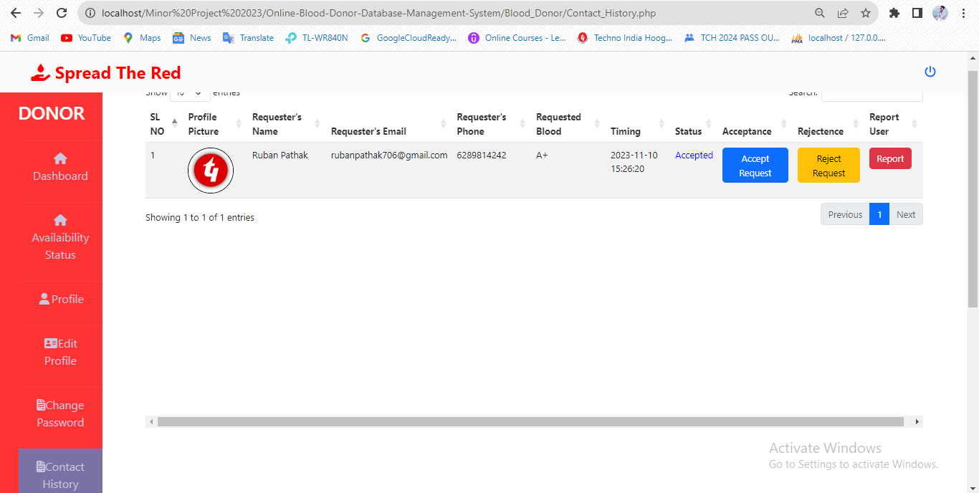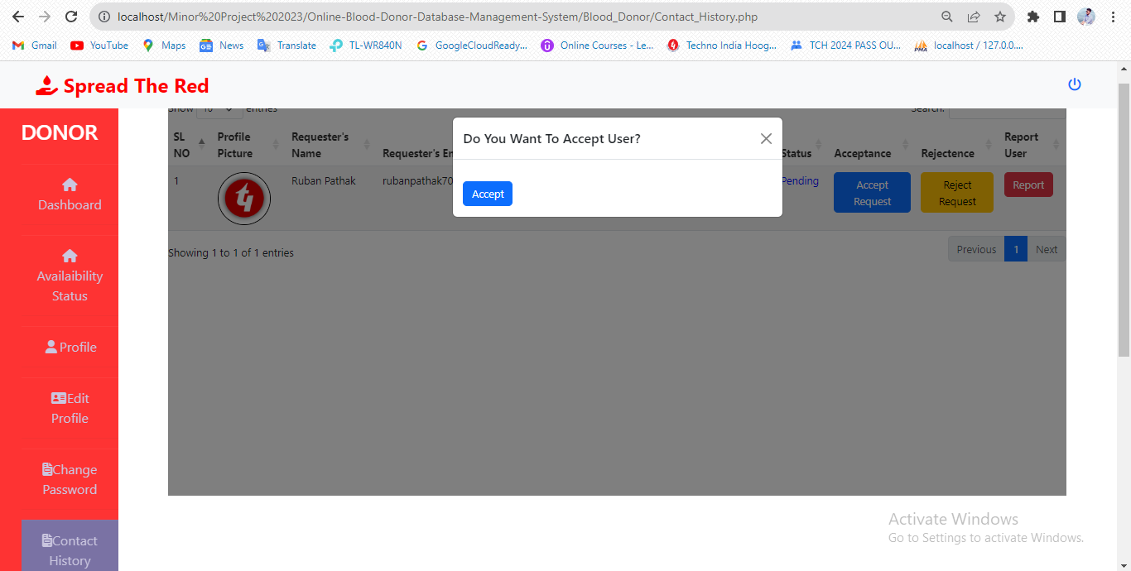

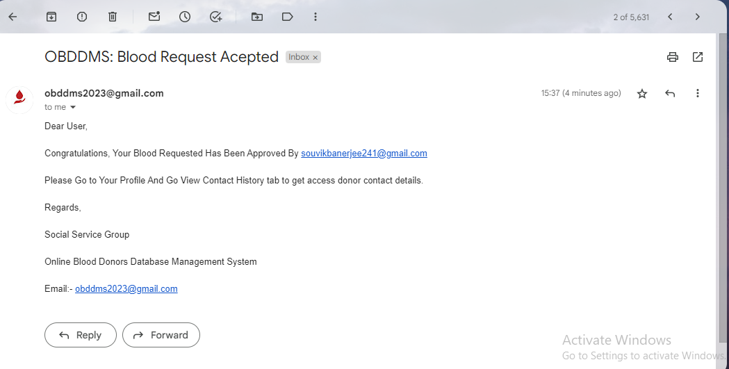

* **Test Case 6 SLNO 2:-**

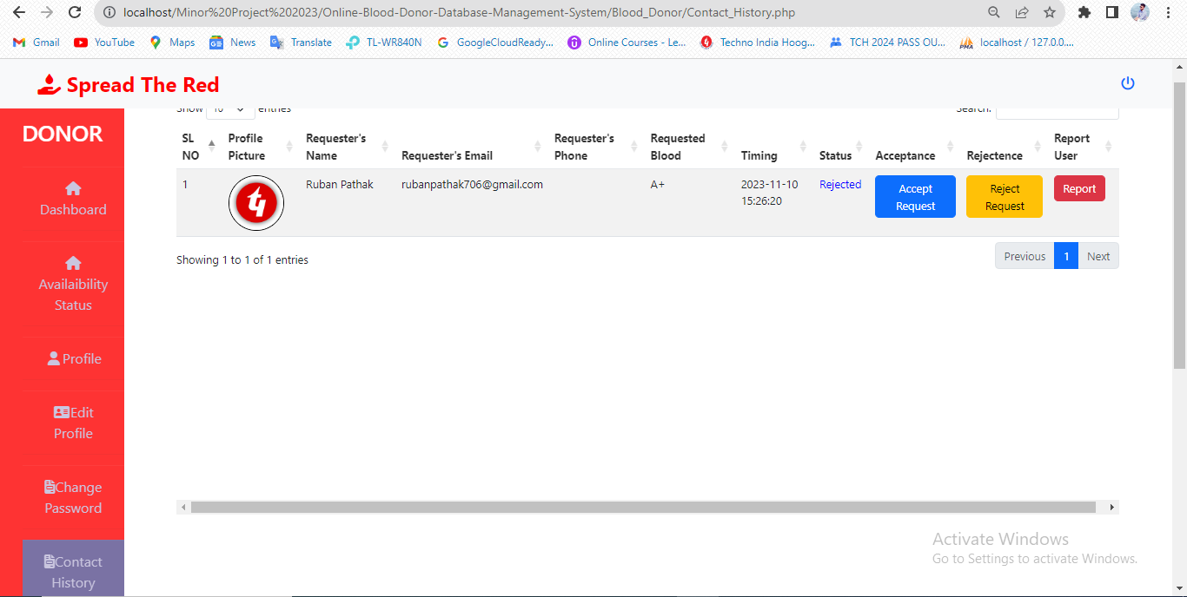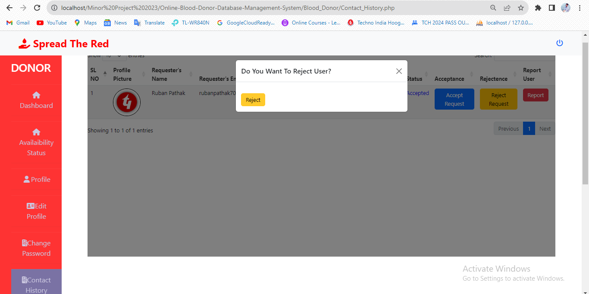



* **Test Case 6 SLNO 3:-**

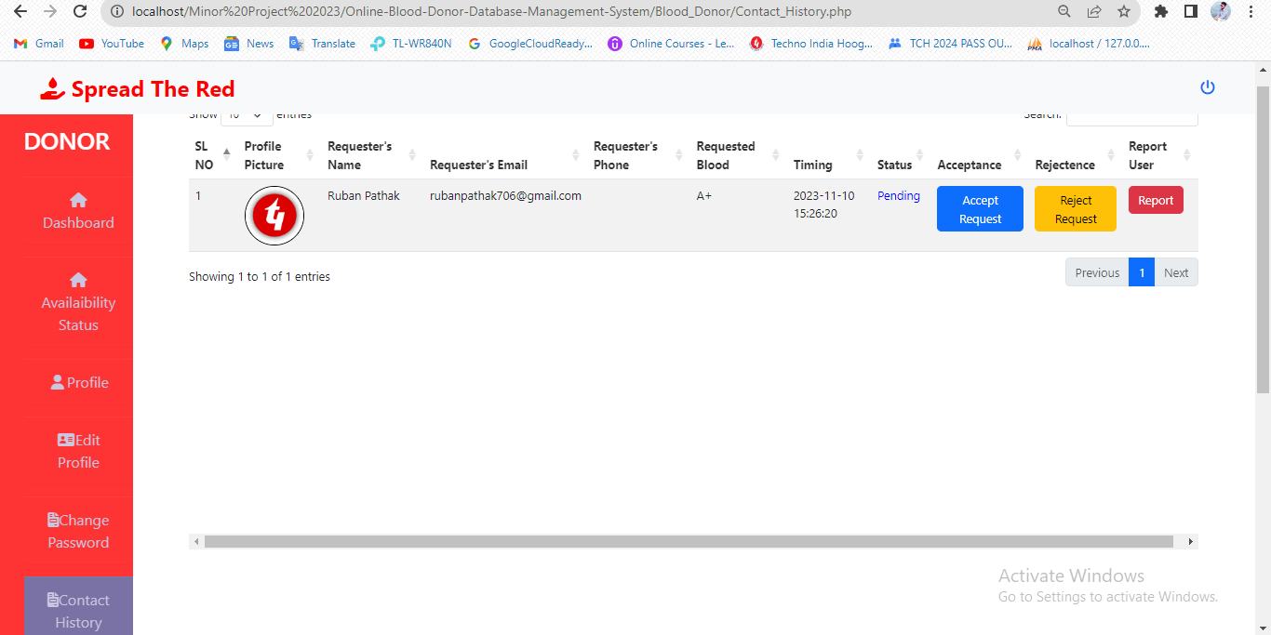

**11.7 *Test Case NO:- 7:-***

**Test Case Name:- Search Facility**

|  |  |  |  |  |
| --- | --- | --- | --- | --- |
| **Test Case NO** | **Test Data** | **Expected** | **Actual** | **Status**  **(pass / fail)** |
| 1 | <correct blood group>  <correct pin code> | Donors profiles will be available. | Donors profiles will be available. | pass |
| 2 | <incorrect blood group>  <incorrect pin code> | Donors profiles will not be available. | Donors profiles will not be available. | pass |

* **Test Case 7 SLNO 1:-**

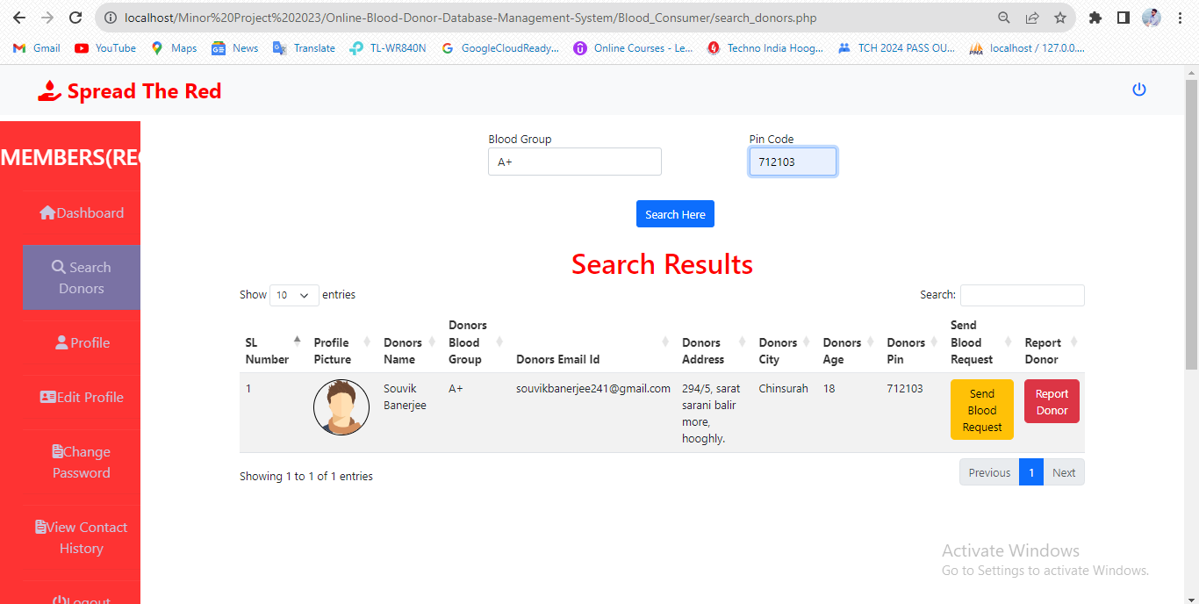

* **Test Case 7 SLNO 2:-**

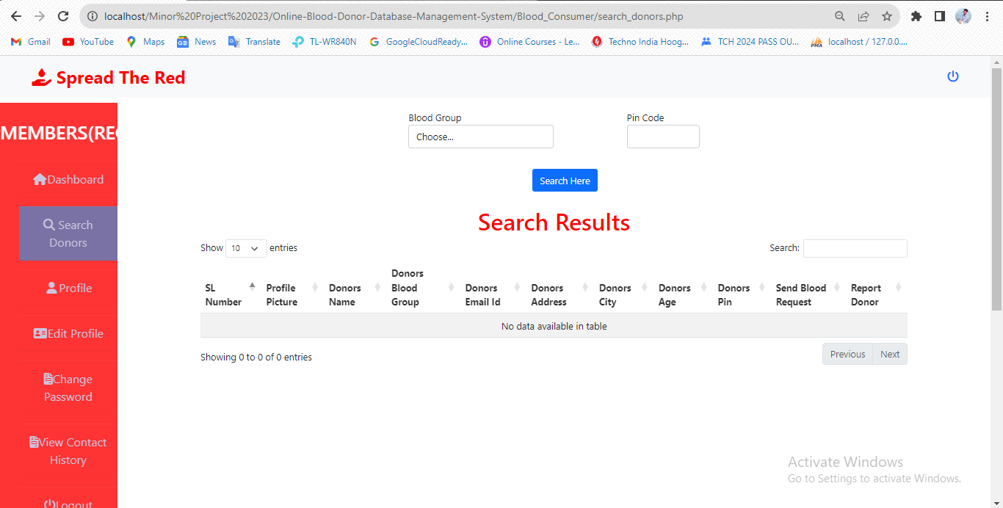

**11.8 *Test Case NO:- 8:-***

**Test Case Name:- Send Blood Request And Report Button**

|  |  |  |  |  |
| --- | --- | --- | --- | --- |
| **Test Case NO** | **Test Data** | **Expected** | **Actual** | **Status**  **(pass / fail)** |
| 1 | <Send request button> | An email will sent to the donor. | An email will sent to the donor. | Pass |
| 2 | <Sent report without description> | Report cannot be sent | Report cannot be sent | Pass |
| 3 | <Sent report with description> | Report Sent | Report Sent | Pass |

* 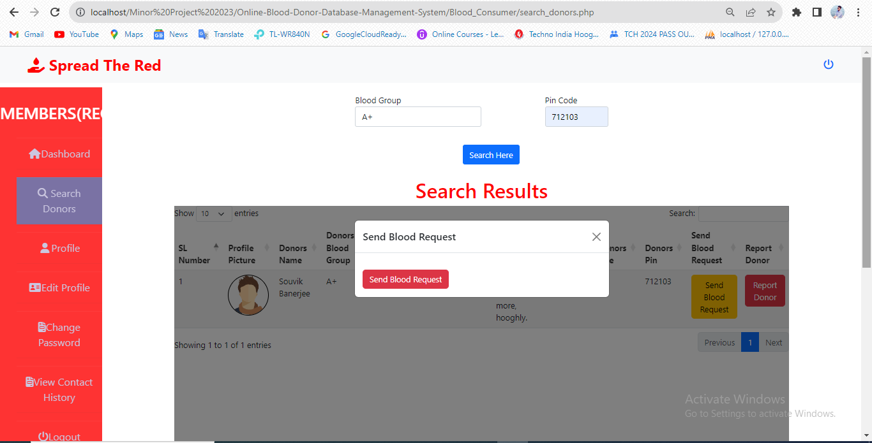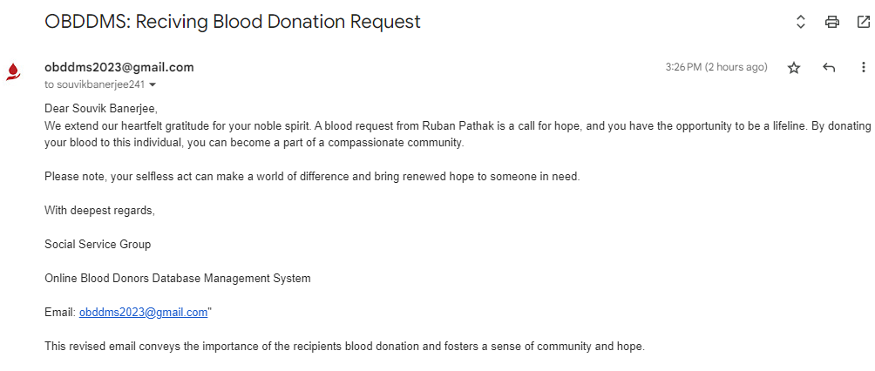**Test Case 8 SLNO 1:-**
* **Test Case 8 SLNO 2:-**

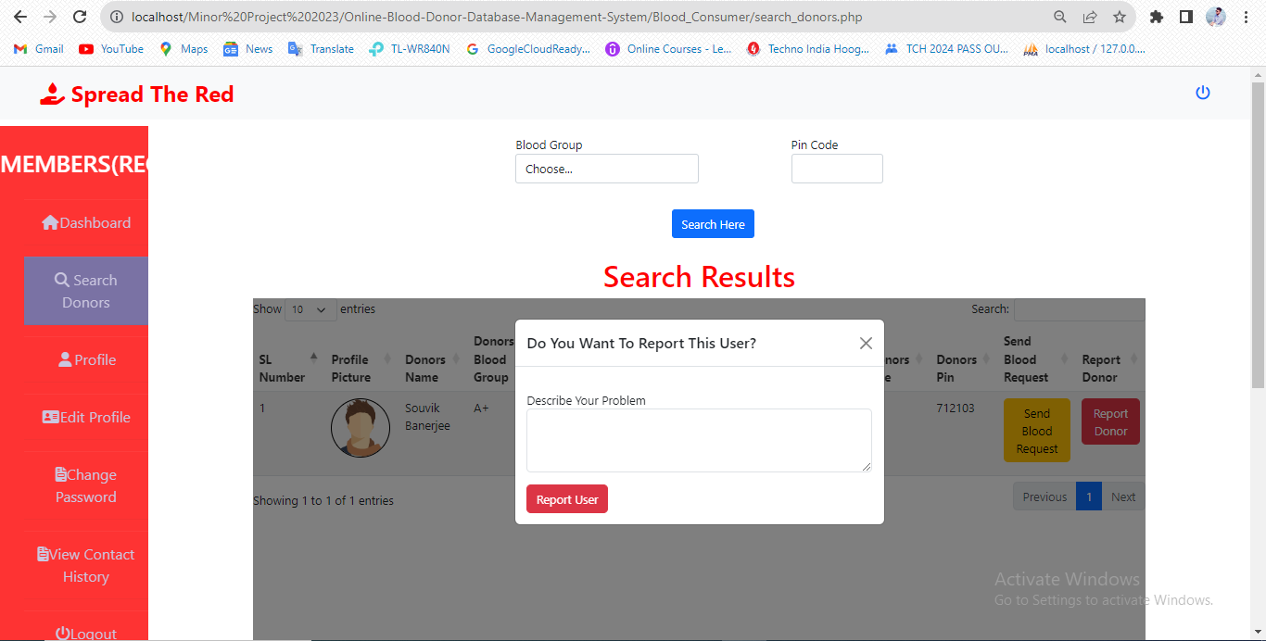

* 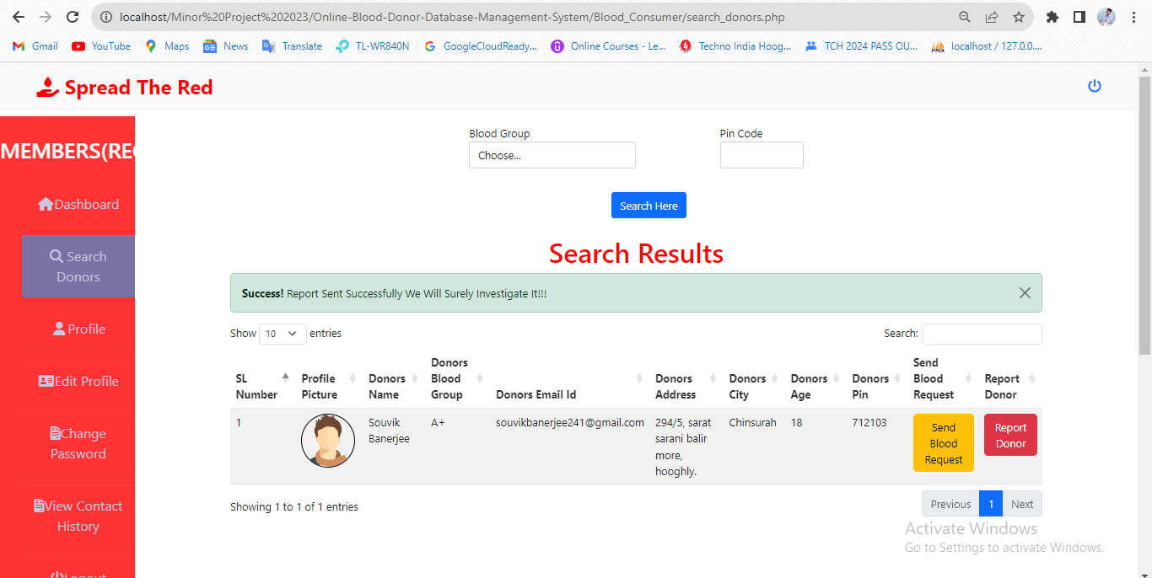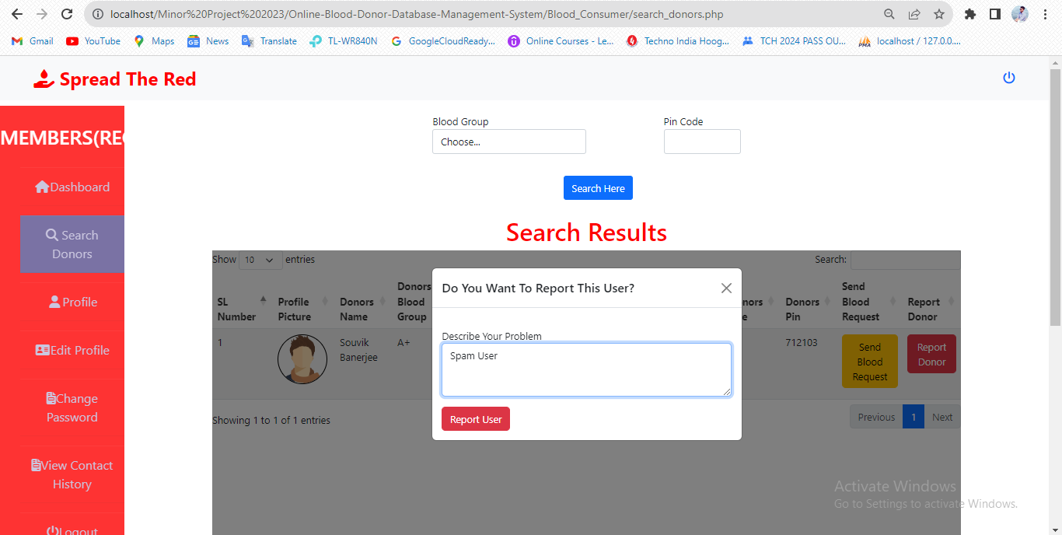**Test Case 8 SLNO 3:-**

**11.9 *Test Case NO:- 9:-***

**Test Case Name:- Pending/Rejected/Accepted Blood Request**

|  |  |  |  |  |
| --- | --- | --- | --- | --- |
| **Test Case NO** | **Test Data** | **Expected** | **Actual** | **Status**  **(pass / fail)** |
| 1 | <Pending> | Donor’s Phone is hidden | Donor’s Phone is hidden | Pass |
| 2 | <accepted> | Donor’s Phone is shown | Donor’s Phone is shown | Pass |
| 3 | <rejected> | Donor’s Phone is hidden | Donor’s Phone is hidden | Pass |

* **Test Case 9 SLNO 1:-**

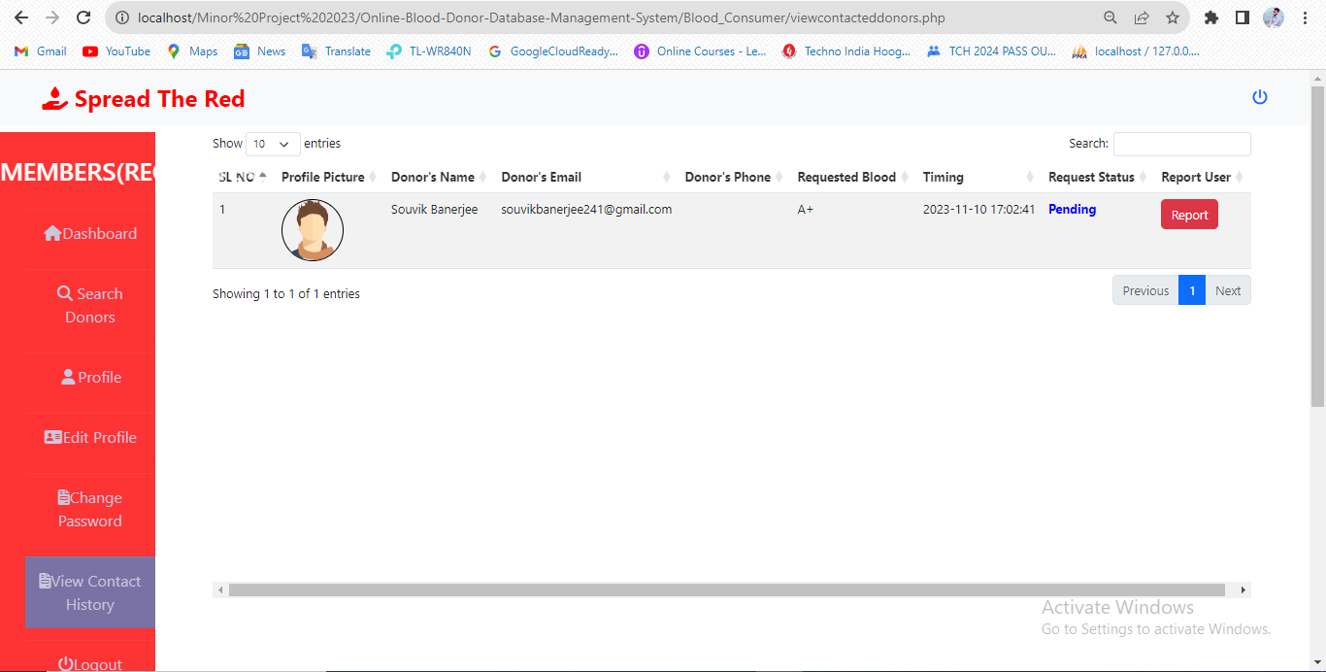

* **Test Case 9 SLNO 2:-**

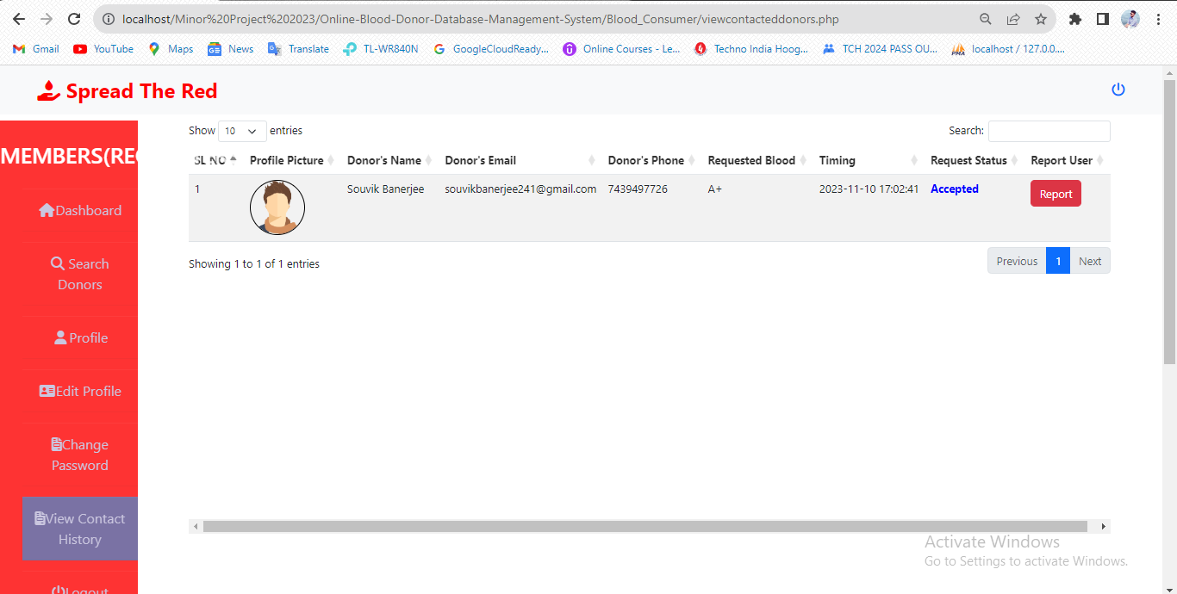

* **Test Case 9 SLNO 3:-**

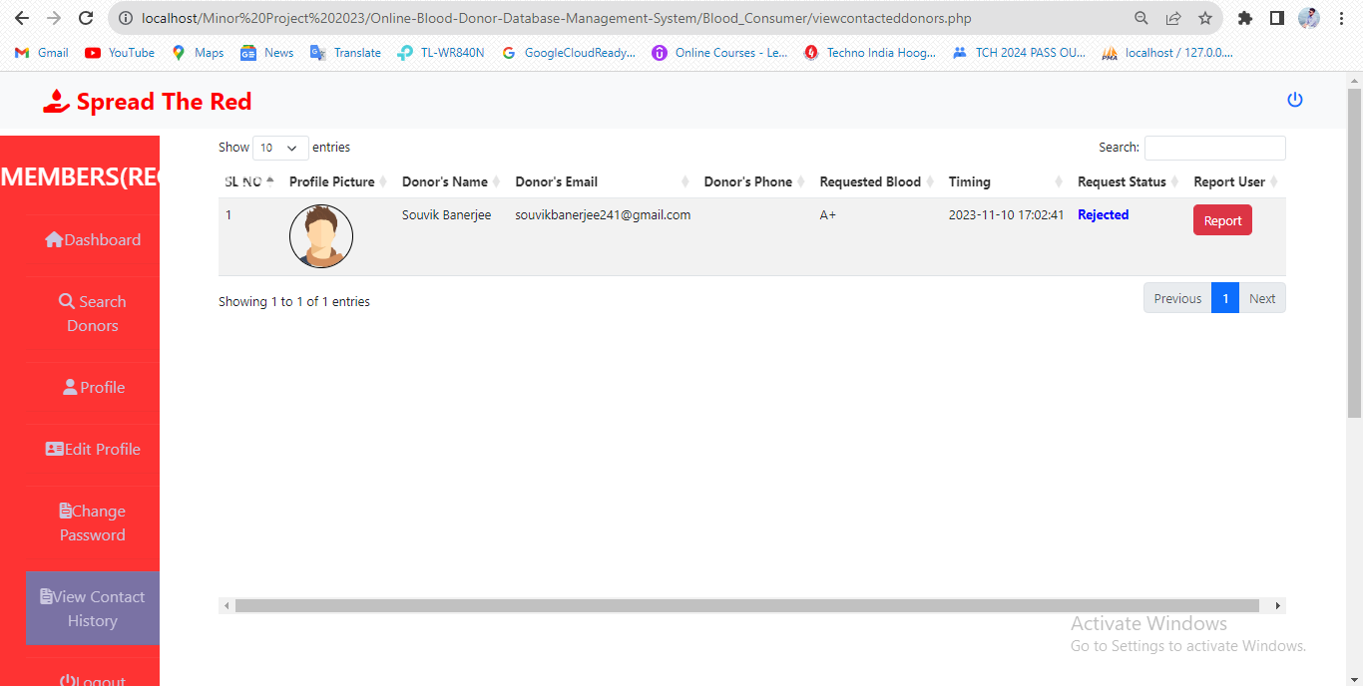

**11.10 *Test Case NO:- 10:-***

**Test Case Name:- Send Warning (Admin Panel)**

|  |  |  |  |  |
| --- | --- | --- | --- | --- |
| **Test Case NO** | **Test Data** | **Expected** | **Actual** | **Status**  **(pass / fail)** |
| 1 | <send warning> | Email Of Warning Can Be Sent | Email Of Warning Can Be Sent | Pass |

* **Test Case 10 SLNO 1:-**

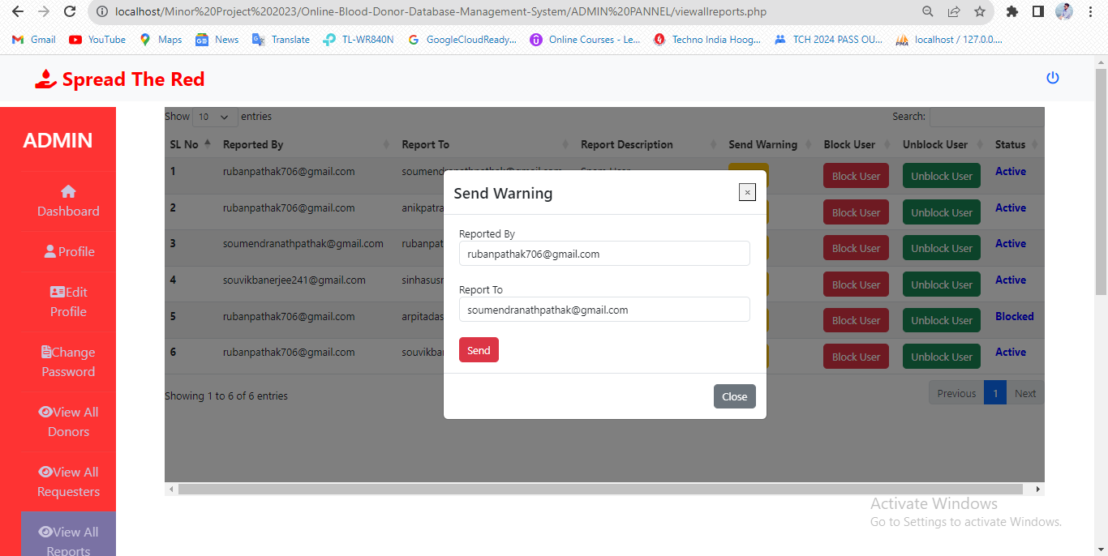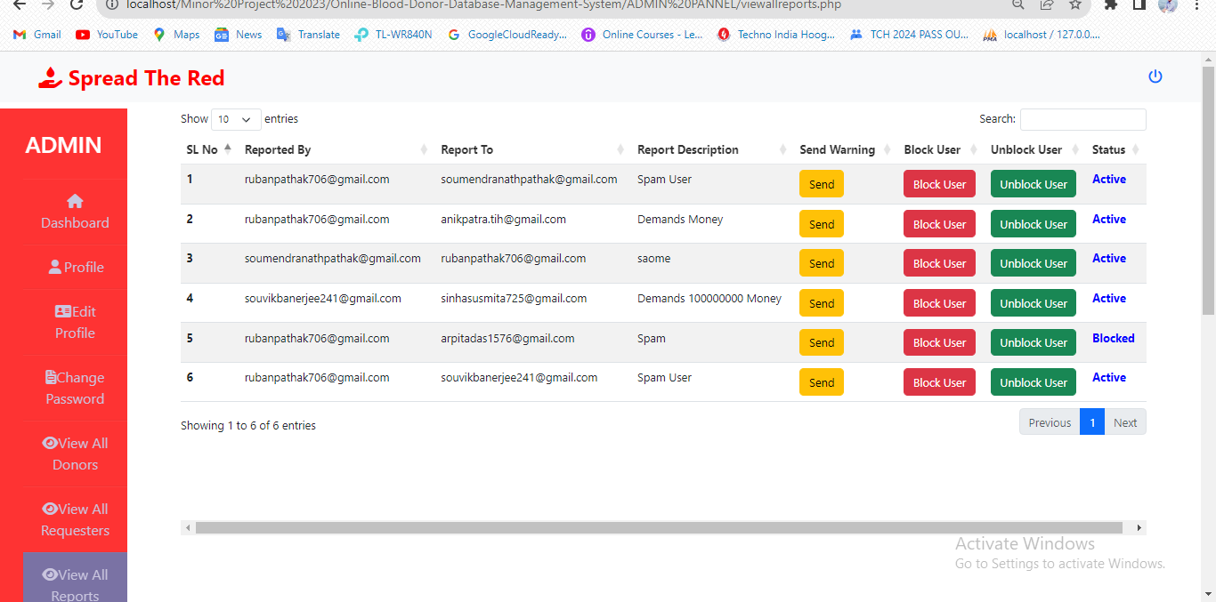

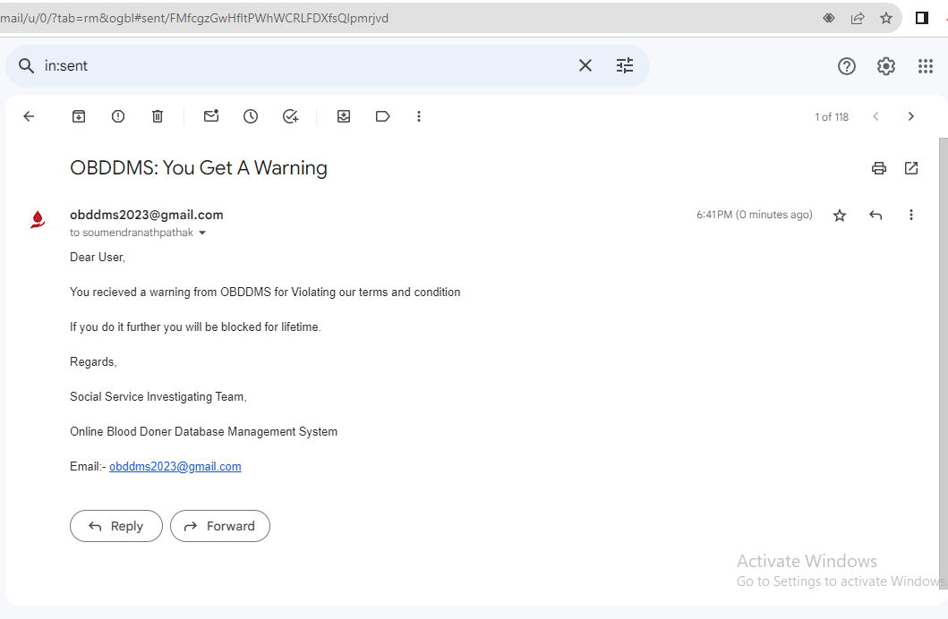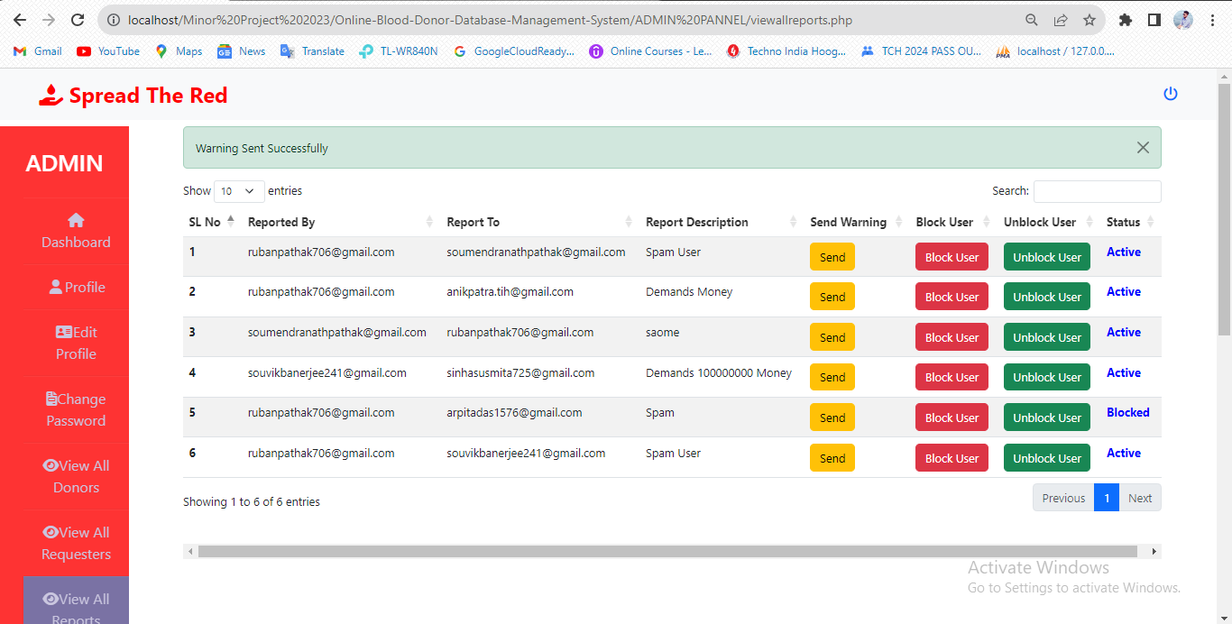

**11.11 *Test Case NO:- 11:-***

**Test Case Name:- Block/Unblock (Admin Panel)**

|  |  |  |  |  |
| --- | --- | --- | --- | --- |
| **Test Case NO** | **Test Data** | **Expected** | **Actual** | **Status**  **(pass / fail)** |
| 1 | <block> | User can be blocked and an email will be sent | User can be blocked and an email will be sent | Pass |
| 2 | <unblock> | User can be unblocked and an email will be sent | User can be unblocked and an email will be sent | Pass |

* 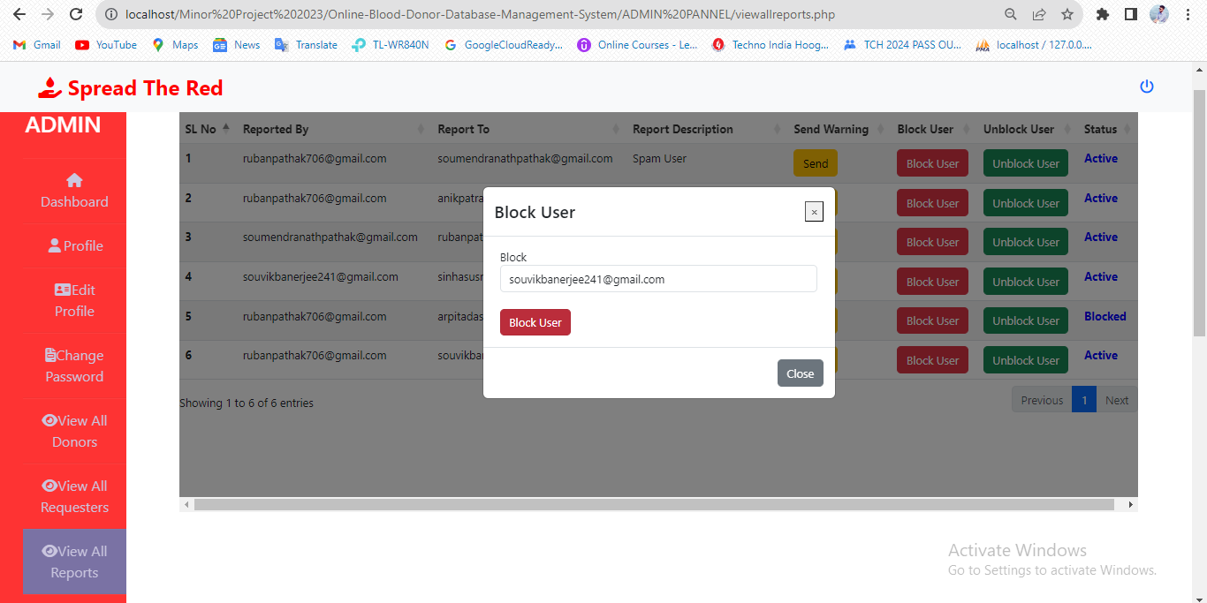**Test Case 11 SLNO 1:-**



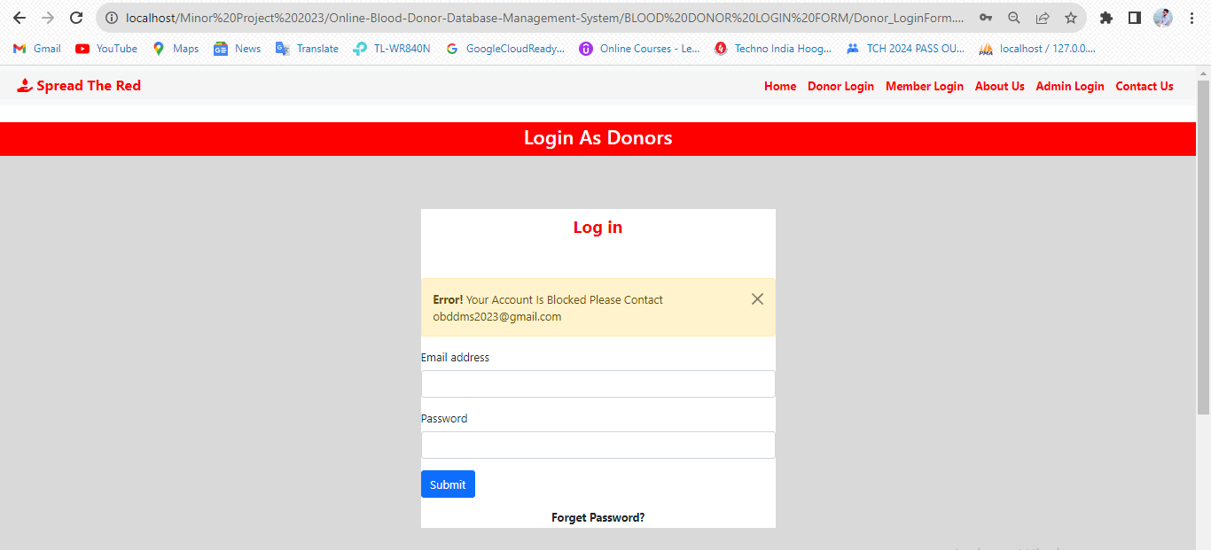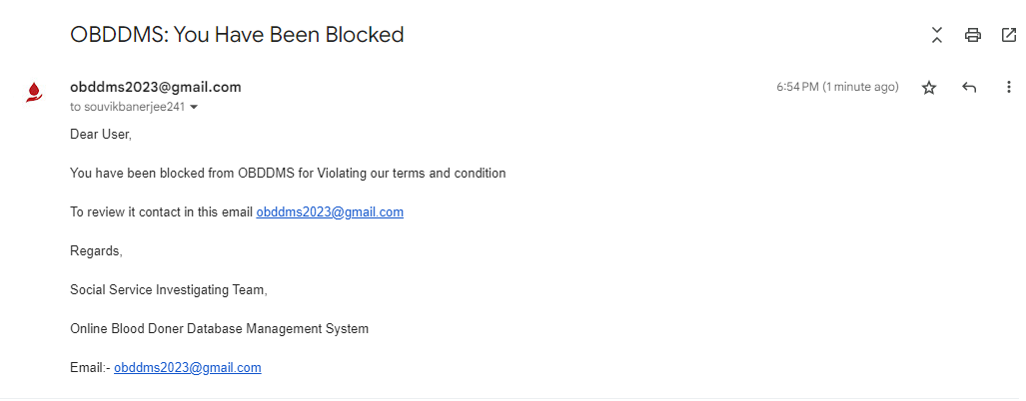

* **Test Case 11 SLNO 2:-**

